July 25th. 2010
Hi
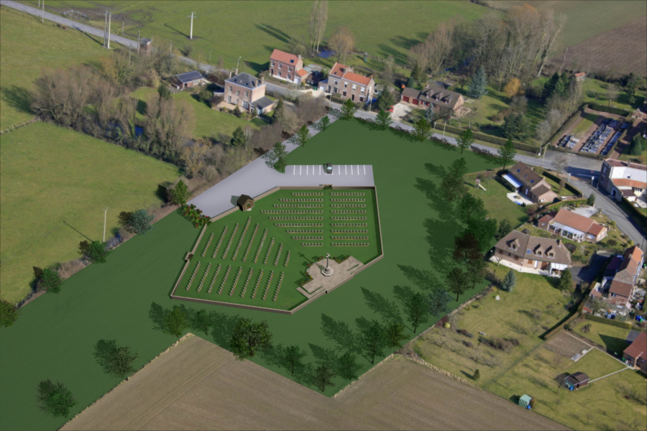
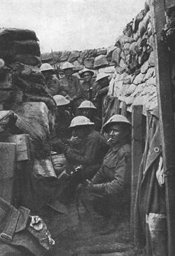
Last Sunday saw the opening of a WWI cemetery at Fromelles in Northern France. This is for the British and Australian soldiers who were killed in a battle there in 1916 there and who were buried in a pit (by German soldiers). It was a suicidal battle (as were many in WWI); of the (Australian) soldiers in the photo on the right, only three survived, with serious injuries. Many, but not all, of the buried soldiers were able to be identified.
As my passport is due to expire in October, I need to get it renewed, so on Tuesday I got new photos taken; the picture looks no worse than that of five years ago! Now I have to find someone who knows me and who belongs to one of the few categories (NZ citizen, teacher, policeman, etc.) who can sign the photo as being me. Surprisingly, there is no-one here I can call on, so I will probably have to go to the Faculty of Education at CUHK to find someone. The passports are now valid for only five years and are much more expensive than before. Also, as most countries require at least six months validity for entry, the life of the passport is effectively only 4.5 years or less and a new passport becomes valid from the date of renewal rather than the date of expiry. I actually e-mailed the NZ government and suggested that the date of expiry be used (as is done with with HK driving licenses; coincidently I received my renewed HK license close to the day I sent this e-mail) but they said this couldn't be done (which is correct under the present wording of the regulations, but would be changed if enough people complained). So at the moment, I am unable to travel as my current passport does not have enough time validity.
More problems with food from China. This time, drops of liquid mercury were found in a popular brand of canned pork from China. Really!
HK has been brushed by a typhoon, which though not a direct hit, brought a lot of rain and caused a lot of flooding in places. Several people were drowned including two who were fishing in the Shing Mun reservoir (the one we visited, Leonie and Tom). However, what HK experienced, pales in comparison with the floods that are continuing to cause tremendous damage to parts of central and southern China. Whole villages and cities have been inundated. The Three Gorges dam on the Yangtze river, which was built not only to provide electricity but to control floods on the river, just managed to control the upstream floods, but all the water that had to be released caused a lot of damage downstream. Remember I told you a few weeks ago about the guy who was swimming down the Yangtze from Wuhan (downstream from the dam) to Shanghai? I have not heard anything about him recently but suspect be would have to have abandoned it. The last report was a couple of weeks ago when he had completed about ¼ of the swim.
On Friday, a limited number of iPads went on sale in HK. They had all gone within an hour or so. I am thinking of getting one sometime particularly for reading e-books, e-mail and the Wi-fi internet when travelling. Other e-readers, such as the Kindle, are cheaper but do not support colour as does the iPad. Tthe memory on the iPad models ranges from just 16 to 64 GB which seems very small. Even my computer has about 150 GB, which is small compared with current computers.

You are probably aware that an election campaign is under way in Australia. There was an interesting comment on ABC (Australia) news the other night about the antics of the two leaders of the opposition party, whose names are Tony Abbott and Peter Costello, which were not unlike those of 'Abbott and Costello', a pair of US film comedians. You are probably too young to have heard of them, but when I was very young, we would sometimes go to Saturday morning kids' shows where the first half would usually include some comedy act (such as 'Abbott and Costello', 'Laurel and Hardy' or 'The three Stooges' – which you may also never have heard of) which we always loved. For a modern dialogue about computers that Abbott and Costello might have had were they alive go to the following website. I liked it.
http://growingbolder.com/articles/technology/computers/abbott-and-costello-today-136126.htmlcomments
Also in Australia, the Wallabies beat the Springboks 30-13 yesterday. So the Boks now have three losses out of three games and no points. Given the latest result, perhaps the two recent AB victories were due to Bok weakness rather rather than real AB superiority.
In the letter last year, I wrote about the USB drive (2GB) which HSBC had given me. Did I mention that I took it to NZ with files on it, but that it packed up while I was there, fortunately after I had either used or transferred files to Uncle Bruce's and Keith's computers. HSBC must give out junk. A couple of years ago I got a Samsung DVD player from them which packed up soon after getting it; as it couldn't be fixed, it had to be replaced by Samsung.
Cheers

